**FRESH TEACHER'S E-LIBRARY**

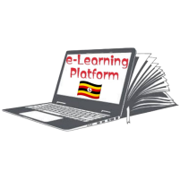 **BEGINNING OF TERM III EXAMINATION 2023**

**PRIMARY ONE**

**RELIGIOUS EDUCATION**

**My name is _____________________________________________**

**I am in __________________________________________________**

**My school is ____________________________________________**

1. **Draw these things which give us light.**

|  |  |  |  |
| --- | --- | --- | --- |
|  |  |  |  |
| star | moon | lamp | candle |

1. Moslems go to the _______________on Friday.
2. Christians go the ______________on Sunday.

(town, mosque, shop, church)

1. **Circle the uses of water at home.**

cooking food, writing, sleeping, clapping, bathing, drinking, dancing

1. __________________and _________________lived in the garden of Eden. (Adam, Kato, Eva)
2. **Draw these things man has made.**

|  |  |  |  |
| --- | --- | --- | --- |
|  |  |  |  |
| chair | radio | mat | book |

1. Who died on the cross? _________________________________

(God, Allah, Jesus)

1. Name three people found at home.
2. _______________________________________________________
3. _________________________________________________________
4. _________________________________________________________
5. God is in ______________________ and everywhere.(heaven,hell)
6. Good children ____________________their parents.
7. **Match our senses to their uses.**

eyestasting

nose hearing

tongue feeling

ears seeing

skin smelling

1. Rain gives us ___________ (soil, water)
2. **Underline the Christian names.**

Ali, Joseph, Abdul, Alice, Mohammed, Mary, Musoke

1. 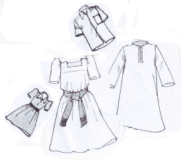**Match the needs of people.**

water /drinks

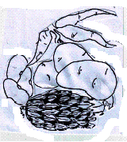

shelter

D:\Local Disk F\New folder\KIBUUKA 2023\pictures\DISAN PICS\pics\houses banglow 2.bmpD:\Local Disk F\New folder\ODONGO\JIREH\DISAN 2020\pic\pics\houses hut 3.bmpfood

D:\Local Disk F\New folder\DISAN 2020\pic\pics\cup water.png

clothes

1. **Name the things we use to clean our bodies.**

|  |  |  |  |
| --- | --- | --- | --- |
| D:\Local Disk F\New folder\ABUSHA 2019\BECKY PICS\NEW PICS\MY PHOTOS\PICTURES\LISA EVE\soap.png | D:\Local Disk F\New folder\SECRETARY\NEW PICS\MY PHOTOS\PICTURES\comb final 2 - Copy - Copy.png | D:\Local Disk F\New folder\KIBUUKA FOLDER\images\kibuuka pic\TOOTH BRUSH.jpg | D:\Local Disk F\New folder\KIBUUKA 2023\pictures\kibuuka pic\tooth paste.jpg |
|  |  |  |  |
| D:\Local Disk F\New folder\KIBUUKA FOLDER\images\DISAN PICS\pics\backet of water.jpg |  |  |  |
|  |  |  |  |

**(comb, soap, tooth paste, Vaseline, handkerchief, water, brush, tooth brush)**

1. **Match animals to their young ones.**

cow lamb

duck piglet

pig kid

sheep calf

goat duckling

**\*\*\*\* GOD BLESS YOU\*\*\*\***